Ideation Phase
Empathy Map Canvas
Date | November 2, 2025
Team ID | F53C03230D9D3649CD4402B24FF15FEB
project Name | Educational organization using ServiceNow

User Persona: School Administrator

- SAYS:
  - "Where is the admission file for this student?"
  - "I have to re-enter this same address in three different spreadsheets."
  - "Did I calculate this student's total marks correctly?"
  - "I need to know how many students are in the 'Joined' status by tomorrow."
- THINKS:
  - "I'm so worried I'll make a typo on a grade report."
  - "This manual data entry is taking up my entire day."
  - "There must be a faster, more professional way to do this."
  - "I wish I could just look up a student and see everything about them in one place."

- FEELS:
  - Frustrated with repetitive tasks.
  - Overwhelmed during admission and exam seasons.
  - Stressed about the accuracy of the data.
  - Responsible for maintaining correct student records.
- DOES:
  - Manually copies data from paper forms into Excel.
  - Uses a calculator to total student marks.
  - Spends hours cross-checking different lists and files.
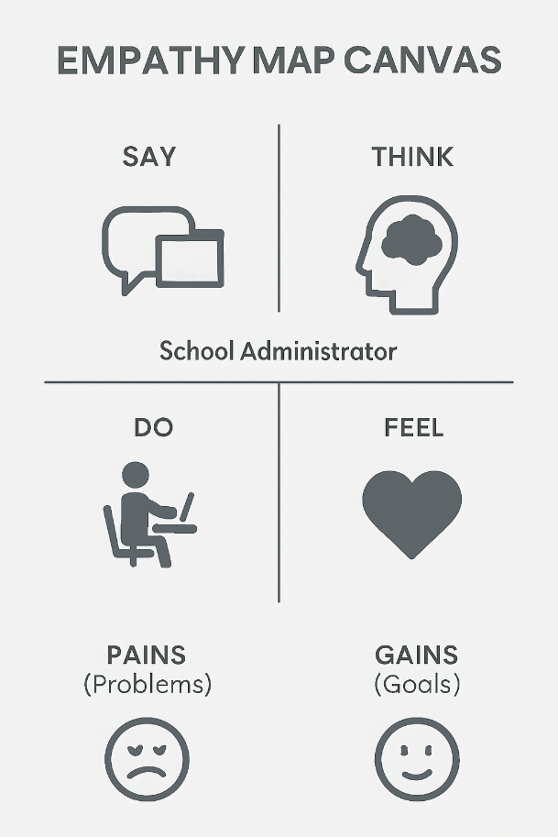
  - Answers phone calls from parents asking for status updates.
- PAINS (Problems):
  - High risk of human error in calculations and data entry.
  - Incredibly time-consuming.
  - No central view; data is scattered.
  - Difficult to generate reports quickly.
- GAINS (Goals):
  - A single, reliable system for all student data.
  - Automated calculations (Total, Percentage) to ensure accuracy.
  - A clear, visual way to track admission status.
  - Faster data entry (e.g., pincode auto-fills address).
  - More time to focus on valuable work.

